Teller-Park
Conservation District

2012
Annual Meeting

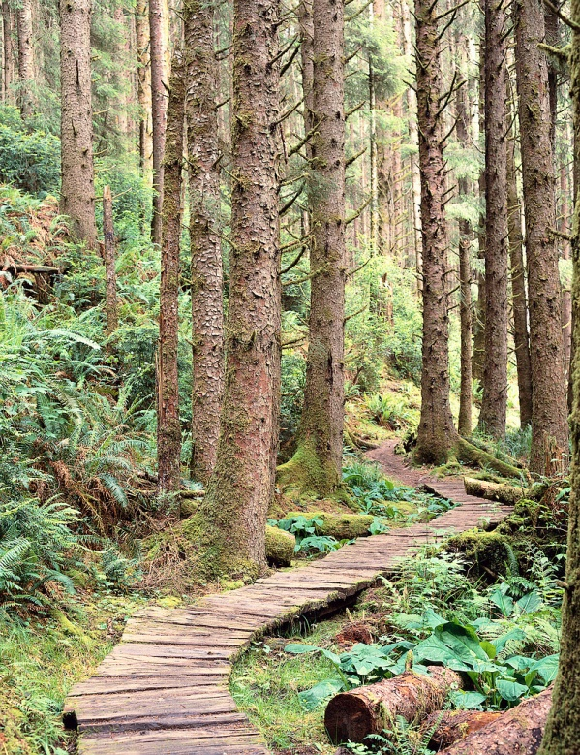

Saturday, September 22
9:00 am – 11:30 am
*Florissant Grange Hall*
2009 County Road
(1 block east of Hwy 24)
Light refreshments served

Featuring Guest Speakers:

Tom Troxel
Executive Director,
Intermountain Forest Association
Dan Casey
Casey Lumber, Woodland Park
Matt Matwijec
Colorado State Forest Service

Tom and Dan will discuss the history of forest management in Colorado, factors contributing to bark beetle epidemics and fires, the importance of desired conditions in forest planning & the role of forest product companies in achieving forest management objectives for the national forests and private landowners.
Matt will discuss fire behavior and creating defensible space for large and small landowners.

All are Welcome to this FREE Event!

RSVP by September 17th to:
Pat Galvin 719-686-9405 or
pat.galvin@co.nacdnet.net

